Angular cli

# Angular cli installations guides

1. **npm install –g @angular/cli.**

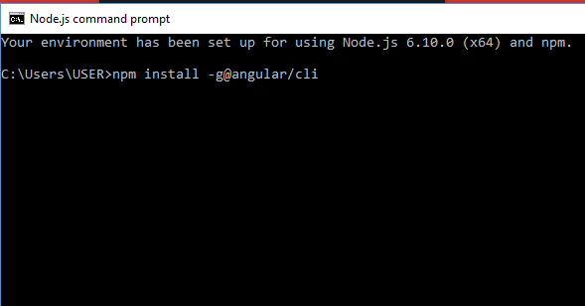

1. **check Angular cli version**

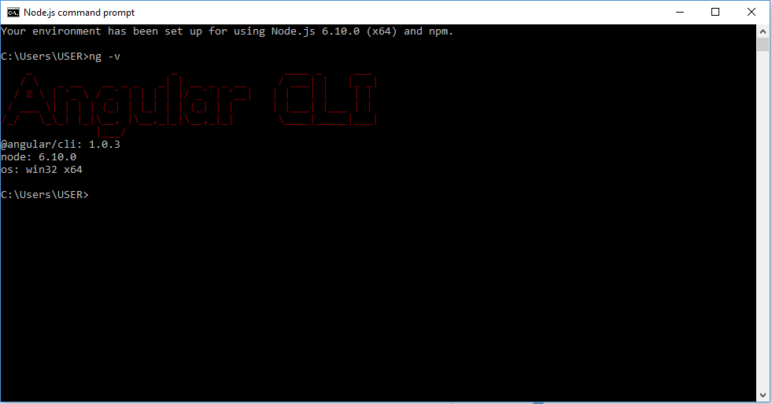

1. **ng new PROJECT NAMW**

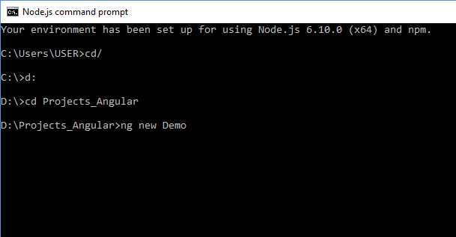

1. **cd PROJECT NAME**
2. **ng serve**

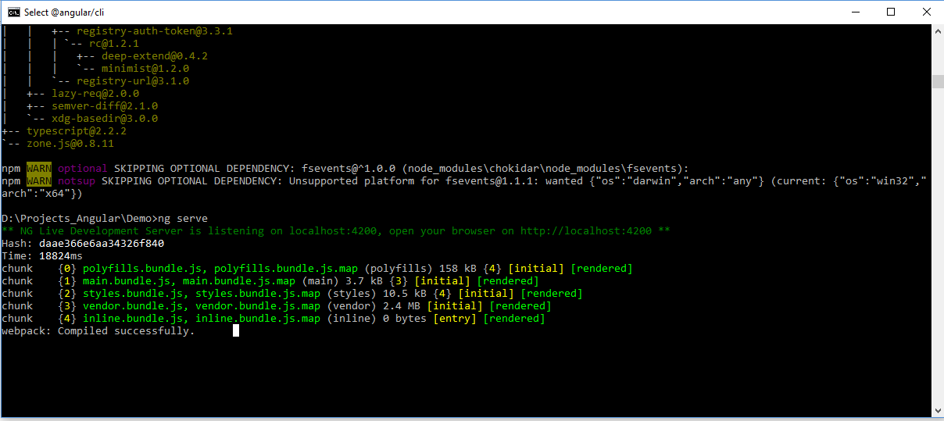

Output:

